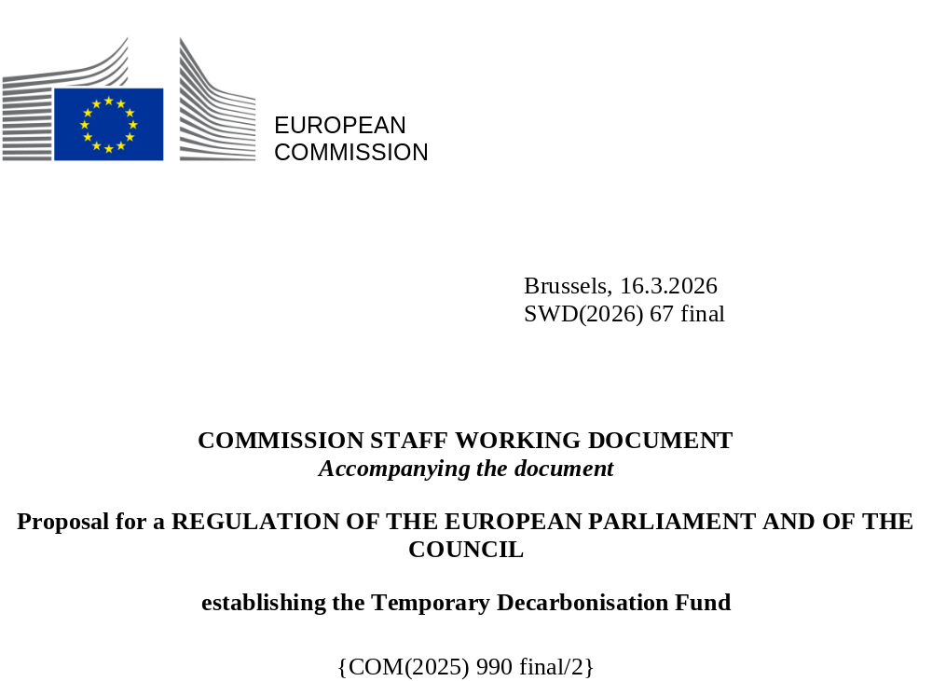

Contents
1. Introduction: political and legal context 2
2. Problem definition 3
3. Determination of eligibility 4
3.1. Derivation of indicators to determine remaining carbon leakage risks 4
3.1.1. Background: Approach to determine the carbon leakage list in phase III and phase IV of the EU ETS 4
3.1.2. Indicators for remaining carbon leakage risks 4
3.2. Proposed approach to determine the remaining carbon leakage risk 5
3.3. Preferred option to determine eligibility of goods for the measure 5
3.4. Alternative option to determine eligibility of goods for the measure 6
4. A targeted approach for specific national circumstances 7
5. Proposed conditionality design 8
6. Engagement with stakeholders 9
Annex 1: proposed list of eligible goods and respective TDFCL indicator 11

Introduction: political and legal context
Regulation (EU) 2021/1119 of the European Parliament and of the Council (‘the European Climate Law’) sets a legally binding economy-wide target of net zero greenhouse gas emissions at the latest by 2050, and an intermediate target of reducing net greenhouse gas emissions by at least 55% by 2030, compared to 1990 levels.
In 2025, the European Commission proposed a target of a 90% reduction in net greenhouse gas (GHG) emissions by 2040, compared to 1990 levels. This proposed target takes full account of the current economic, security and geopolitical landscape in alignment with the EU Competitiveness Compass, and the Clean Industrial Deal. It aims to provide the necessary predictability and stability for investments in the EU's clean energy transition and for driving industrial competitiveness.
The emissions of large industrial installations are regulated by the EU Emissions Trading System (ETS). The current EU ETS legislation sets an emission reduction target of 62% for stationary installations, aviation and maritime (ETS1) by 2030 compared to 2005. In 2026, the Commission is planning to conduct a comprehensive review of the EU ETS, assessing how the EU ETS can best be adjusted to promote cost-effective emission reductions in the covered sectors in line with climate neutrality in 2050 and the intermediate target for 2040.
Over the coming decade, and to achieve climate neutrality by 2050, industry will have to go through a significant transformation to decarbonise and switch to cleaner and more energy efficient technologies. This transformation requires stepping up investments, while remaining competitive and affordable. The deployment, pace and scaling-up of existing and new technologies such as electrification, carbon removals and carbon capture and utilisation will need both public and private support.
In line with the overall reduction targets, and considering that free allocation dampens the price signal to promote cost-effective emission reductions, the current EU ETS1 framework has built in several mechanisms to reduce free allocation until 2030, including the update of benchmarks as well as the application of the cross-sectoral correction factor. For a limited set of sectors (i.e. iron & steel, aluminium, cement, fertiliser, hydrogen), free allocation is additionally reduced by the CBAM factor. Preliminary estimations suggest that a total of 15 million allowances less would be allocated free of charge. Assuming a carbon price of EUR 95/tonne, this corresponds to an estimated EUR 1.4 billion. This would constitute the maximum budget needed for the proposed measure (if all CBAM goods were covered).
For these sectors, the Carbon Border Adjustment Mechanism (CBAM) is, from 2026 onwards, gradually phased in as a complementary form of protection against the risk of carbon leakage. The CBAM addresses import-related carbon leakage risks for these sectors. The remaining risk of carbon leakage is not fully prevented by Regulation (EU) 2023/956 of the European Parliament and of the Council and should therefore be addressed through additional measures supporting the transition and promoting the decarbonisation of industrial sectors. Decarbonisation investments can help reduce the exposure of these operators to such carbon leakage risks in the mid- and long-term. The objective of the present proposal is thus to temporarily support, during the production years 2026 and 2027, operators producing goods associated with a particularly elevated remaining carbon leakage risk to effectively invest in decarbonisation measures. A more permanent solution may be envisaged in the upcoming revision of the ETS Directive.
Action at Union level is necessary to address the abovementioned risks in a consistent manner across Member States. Measures at national level could lead to uncoordinated support across the Union, thus leading to distortions in the internal market and weakening the overall effectiveness of the EU ETS.
The measure to be proposed should be implemented quickly to provide legal certainty, and to avoid undue administrative burden. The proposed temporary decarbonisation investment support should moreover be precisely targeted to production of goods with a heightened level of remaining carbon leakage risks, in order to be proportionate and in order to avoid market distortions. The present document describes how these needs have been taken into account in the design of the proposed measure.

Problem definition
The decrease in emissions under the EU ETS in recent years was largely driven by the electricity sector. Emissions in the energy intensive industries, on the other hand, experienced only slight decreases, which were also partly explained by decreases in output. The availability and affordability of abatement options in these sectors is not yet at the level of the power sector. This points to a need for investment into decarbonisation measures in these sectors, because these investments are needed to achieve EU climate targets and reduce the risk of carbon leakage.
Effective carbon costs for ETS operators are expected to increase as free allocation is reduced, notably for operators covered by the CBAM factor. This increased price signal for decarbonisation is expected to promote cost-effective GHG emission reductions. However, the production of some goods might bear an increased risk of remaining carbon leakage which is not fully addressed by the CBAM.
For the goods produced to be sold on the EU internal market, the risk of carbon leakage is addressed by the application of the CBAM which will ensure that products produced in third countries and imported to the EU internal market will pay an equivalent carbon price to that payable if the goods were produced in the EU. It can be considered that this balances the impacts of the phase-out of free allocation. However, the production of some goods can still be considered to be exposed to a remaining carbon leakage risk where no equivalent carbon pricing is in place. The reduced Union-wide emissions cap, combined with the gradual phase-out of free allocation provided for in the ETS Directive, requires cost-intensive and rapid adaptations by the industries covered by Directive 2003/87/EC, thereby increasing the short-term risk of carbon leakage. Operators of EU ETS installations producing such goods are expected to need temporary financial support to accelerate investments into decarbonisation measures in order to ensure the effectiveness of the Union’s climate policy and in order to fully address this remaining risk of carbon leakage.

Determination of eligibility

Derivation of indicators to determine remaining carbon leakage risks

Background: Approach to determine the carbon leakage list in phase III and phase IV of the EU ETS
In phase III of the EU ETS, a sector or sub-sector was considered to be at significant risk of carbon leakage if:
- direct and indirect costs induced by the implementation of the directive would increase production cost, calculated as a proportion of the gross value added, by at least 5%; and
- the sector's trade intensity with non-EU countries is above 10%.
A sector or sub-sector was also deemed to be exposed if:
- the sum of direct and indirect additional costs was at least 30%; or
- the non-EU trade intensity was above 30%.
As a result, more than 250 sectors (at NACE 4 level), almost all industry sectors covered by the EU ETS, qualified for the carbon leakage list.
In phase IV, the two separate indicators are replaced by a combined indicator. A sector or sub-sector is deemed to be at risk of carbon leakage if the product of trade intensity and emission intensity exceeds 0.2:
$$trade intensity *emission intensity(\frac{kg{CO}_{2}}{gross value added \left(in €\right)})>0.2$$

The carbon leakage list for phase IV is more focussed with a bit more than 50 sectors at NACE 4 level included in the list, while the list still covers all highly emission-intensive industry sectors.

Indicators for remaining carbon leakage risks
To determine the remaining carbon leakage risk described above, the indicators used in phase III and phase IV of the EU ETS need to be adjusted.
In phase III of the EU ETS, one of the two defining criteria was a carbon cost indicator while in phase IV it was an emission intensity indicator. Both approaches are capturing the same potential cause of carbon leakage.
All CBAM goods are deemed to have a significantly high emission intensity. The CBAM Regulation (recital 31) specifies that ‘[t]he goods, to which this Regulation should apply, should be selected after careful analysis of their relevance in terms of cumulated greenhouse gas emissions (...)’. An additional analysis of the emission intensity would thus be redundant.
The trade intensity indicator also required adjustments to focus the measure on the remaining risks after the application of the CBAM.

Proposed approach to determine the remaining carbon leakage risk
The proposed decarbonisation fund will provide temporary financial support to operators of EU ETS installations that produce goods included in a pre-defined list of goods considered to be at risk of remaining carbon leakage. In order to define this list of goods at risk, in a first step, the scope of potentially eligible goods is limited to goods listed in Annex I of the Regulation (EU) 2023/956 (except electricity), since these are the goods for which free allocation is subject to the CBAM factor. As specified above, all listed CBAM goods have a significantly high emission intensity. To determine the goods which bear a high degree of risk of remaining carbon leakage, a meaningful and objective indicator, called the “Temporary Decarbonisation Fund Carbon Leakage (‘TDFCL’) indicator”, is applied. Considering the volatility of trade data, an average of the three most recent years (2022-2024) of PRODCOM data is used.

Trade intensity data with Norway, Iceland, Liechtenstein (as part of the EU ETS) and Switzerland (existing linking with the EU ETS) are excluded from the calculation of the TDFCL indicator. Since goods produced in those jurisdictions are subject to an equivalent carbon price to that payable in the EU, and thus the production of goods traded with these countries does not give rise to a risk of carbon leakage. Trade intensity data with the UK were also excluded from the calculation of the TDFCL indicator, since carbon prices in the UK ETS and EU ETS are comparable, and further converging in view of the political intention to link the EU ETS and the UK ETS (see figure 1). Consequently, the remaining carbon leakage risk on the UK market is expected to be very limited.
Figure 1 comparsion of the UK ETS and EU ETS carbon prices (November 2024 - December 2025). Source: International Cabon Action Partnership (ICAP) Allowance Price Explorer, accessed on 4 November 2025.
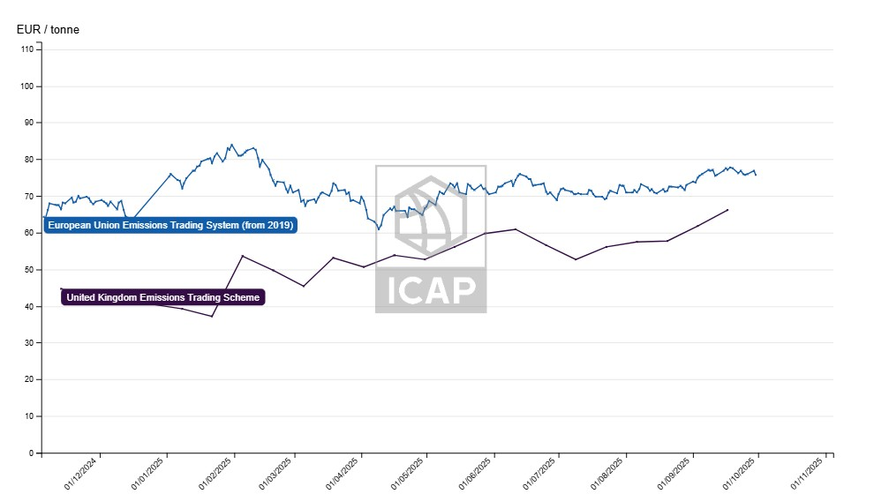

Preferred option to determine eligibility of goods for the measure
The intention of the proposed temporary decarbonisation fund is to provide effective investment support for decarbonisation to operators producing goods for which the remaining carbon leakage risks are the highest, while respecting the limited budget available and avoiding the creation of potential market distortions. A meaningful eligibility threshold is needed to identify the goods which bear a high degree of risk of remaining carbon leakage. Operators of installations producing eligible goods may, conditional to meeting decarbonisation requirements, receive financial support based on the amount of free allowances phased out due to the application of the CBAM factor as defined in Article 10a(1) .
Assuming that the equivalent of 25% of the CBAM revenues will be available, we estimate the maximum available budget to be around EUR 632 million, i.e. EUR 308 million corresponding to 25% of the expected revenues generated by the sale of CBAM certificates related to embedded emissions declared in 2026, and EUR 324 million respectively in relation to embedded emissions declared in 2027. However, these are estimates and the amount available for compensation will depend on the actual CBAM certificates prices and revenue in 2026 and 2027.
The estimated costs for the Temporary Decarbonisation Fund are relatively small, due to the moderate free allocation reduction in 2026 and 2027 (2.5% and 5%). The estimated maximum budget needed if all CBAM goods were covered (EUR 1.4 billion) exceeds the funds available which underlines the need to target the measure by setting a threshold.
The proposed threshold for support is the same as for the trade intensity threshold under Phase III of the EU ETS, when only one indicator is used (30%). This provides for targeted support. Table 1 provides an overview of the number of goods (CN codes) covered, as well as preliminary estimations of the phased-out free allowances covered, and financial support provided as part of the temporary measure. Overall, this threshold strikes the right balance between targeting the support to those goods most exposed to remaining carbon leakage and respecting the available budget.
Table 1 overview of the number of goods (CN codes) covered, as well as preliminary estimations of the phased-out free allowances covered and financial support provided as part of the temporary measure for a threshold of > 30%.
CN codes covered | Estimated phased-out FAs covered | Estimated financial support (2026-2027)
142 CN codes (of 570 analysed, 25%)  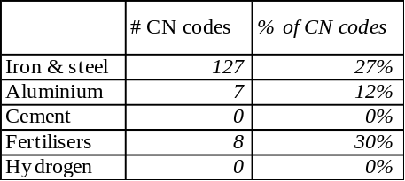 | 14% of phased-out free allowances covered | EUR 190 million, i.e. 30% of assumed maximum available budget

Alternative option to determine eligibility of goods for the measure
An alternative option considered was to target the measure by setting the threshold higher (50%). This option was disregarded since only a very small share of CN codes and phased-out free allowances would be covered, risking that the measure falls short of effectively supporting decarbonisation investments to a sufficient level and thus achieving the objective of preventing carbon leakage.

Table 2 overview of the number of goods (CN codes) covered, as well as preliminary estimations of the phased-out free allowances covered and financial support provided as part of the temporary measure for a threshold of > 50%.
CN codes covered | Phased-out FAs covered | Estimated financial support (2026-2027)
63 CN codes (of 570 analysed, 11%)  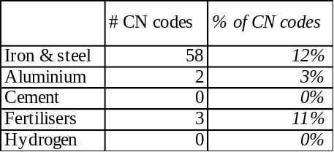 | 0.3% of phased-out free allowances covered | EUR 5 million, i.e. 1% of the MS share of assumed maximum available budget

A targeted approach for specific national circumstances
While the production of certain goods does not have high levels of remaining carbon leakage risks when assessed at an EU-wide level, the remaining carbon leakage risks might nonetheless be significantly higher when assessed at Member State level due to unique national circumstances. In these cases, EU ETS operators producing the affected goods might also be in need of temporary financial support to accelerate decarbonisation investments.
Important factors for determining whether the production of goods is significantly more vulnerable at an individual country level compared to the EU-wide level are geographic circumstances as well as the ratio between value and weight of goods. To account for the specific characteristics of goods with a low ratio of value to weight with regards to the remaining risk of carbon leakage, an opt-in mechanism should be established. While the goods set out in the Annex demonstrate a particularly high Union-wide exposure, this opt-in mechanism should consider national circumstances, including transportation costs. The production of low value/weight goods in specific locations might have a higher remaining carbon leakage risk.
Data from Eurostat (production sold, both in value and quantity, 2022-2024) is used to determine the value/weight ratio per CN code. A preliminary threshold of 150 EUR/tonne is applied to identify goods with a comparatively low value/weight ratio. These goods can be considered to have a potentially significantly higher remaining carbon leakage risk when considered at national level.
Table 3 goods considered to potentially have significantly higher remaining carbon leakage risks at national level, due to a comparatively low value/weight ratio
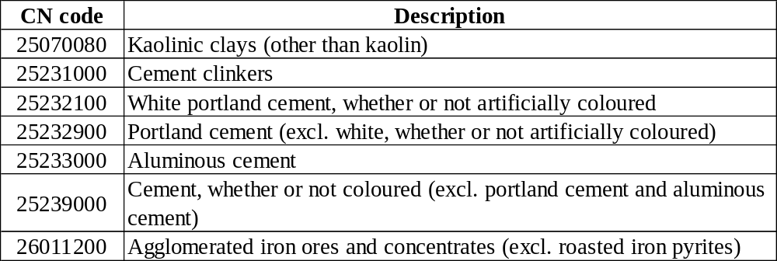
It is proposed to address the associated risk through an opt-in mechanism, allowing Member States to apply for the inclusion of certain CN codes covered by CBAM with a low value/weight ratio in the proposed measure if they can demonstrate that the eligibility criteria foreseen for the Annex of the Regulation are fulfilled at national level. This allows for equal treatment between producers of the same goods within a Member State. It also represents a compromise compared to a more distortive and burdensome alternative of assessing leakage risk for individual installations.

Proposed conditionality design
The objective of the proposed Temporary Decarbonisation Fund is to financially support effective decarbonisation investments by EU ETS operators producing goods which bear a significant remaining carbon leakage risk. The definition of ‘conditionality’ requirements attached to the provision of financial support is thus a central element of the proposed fund. Making support conditional upon investment reflects a growing practice both in State aid guidelines and in the ETS Directive.
To limit the administrative burden of the new measure, and to capitalise on already existing administrative ‘infrastructure’ and data reported for the purpose of free allocation under the EU ETS, various options that build on existing frameworks – from State aid and free allocation practice – were explored. Building on a combination of elements from those frameworks, a design making best use of already reported information is proposed that would allow companies to choose between the following:
- For operators covered by the obligation to conduct an energy audit under the Energy Efficiency Directive (EED): The demonstration of the implementation of all recommendations under Article 11 of Directive 2023/1791/EC or alternatively that the pay-back time for the relevant investments exceeds five years or that the cost of those investments is disproportionate. In the latter case, the operator can demonstrate a legal commitment for investments implementing other measures which lead to greenhouse gas emission reductions equivalent to those recommended by the audit report or by the certified energy management system for the installation concerned; or
- For operators not covered by the obligation to conduct an energy audit under the EED: The conditions above apply if they conduct an energy audit compliant with the minimum criteria set out in Annex VI of the EED; or
- For all operators: The demonstration of a legal commitment made for investments to achieve the targets and milestones referred to in a climate neutrality plan compliant with Implementing Regulation (EU) 2023/2441 and which is at least equivalent to the support amount applied for under this Regulation.
The additional administrative burden of this proposed conditionality design is expected to be limited, while at the same time compliance with the proposed framework bear meaningful decarbonisation potential through targeted investments. More than five thousand EU ETS installations are estimated to already be covered by the EED energy audit requirements, and over three hundred EU ETS installations are estimated to be affected by the CNP conditionality. Around 96% of those installations whose greenhouse gas emission levels are higher than the 80th percentile of emission levels for the relevant product benchmarks relating to the implementation of the fifth subparagraph of Article 10a(1) of Directive 2003/87/EC, submitted their climate-neutrality plan to the competent authority. Around 4% of all installations applying for free allocations applied the 20% reduction due to non-compliance with the energy efficiency conditionality requirements.
On average, 52% of all installations with energy efficiency improvements under Article 8 of the EED indicated that they implemented all measures. This indicates that while operators have already taken significant steps, aimed at improving energy efficiency, there is still room for additional efforts in strengthening energy efficiency measures.
The additional administrative steps that need to be carried out by installations that want to receive support from the TDF include an application to the fund, a proof of meeting the conditionality requirements. In addition, an activity level report already required under the EU ETS needs to be provided at a slightly more granular level to differentiate between production volumes of eligible and non-eligible CBAM goods. The additional administrative burden is, hence, minimal in comparison to the support received and the positive environmental impact of the fund.

Engagement with stakeholders
The Commission is committed to being open and transparent throughout the policy cycle, including in the consultation of stakeholders. The Commission has organised a targeted consultation activity, seeking the specific views of well defined stakeholders. The Commission consulted industry representatives on the plan for a support measure in advance of the proposal, including through a high-level dialogue organised on 28 October.
Overview: consultation activities
Date | Consultation activity | Participants
08 August 2024 | Stakeholder Engagement Questionnaire | Industry representatives
19 September 2025 | CBAM industry breakfast | Industry representatives
22 October 2025 | Stakeholder workshop on carbon leakage risks and eligibility for a support measure | Industry representatives
28 October 2025 | High-Level Dialogue | Industry representatives

During these consultation activities, the Commission informed stakeholders about the planned support measure, including plans for its overall design and reflections about the eligibility for support and the conditions that would need to be fulfilled to receive it.
Stakeholders provided their feedback notably on the following points:
- need for a support measure
  - Some stakeholders pointed out that there is an urgent need for a measure tackling the remaining carbon leakage risk, notably in light of the phase-out of free allocation.
- form of support
  - Many stakeholders asked for a delay of the phase-out of free allocation.
  - Many stakeholders asked not to use State Aid as support mechanism to avoid unequal treatment between operators located in different Member States. Several stakeholders pointed out the importance of ensuring WTO compatibility.
- eligibility for support
  - Some stakeholders mentioned the need to also consider downstream products.
  - Some stakeholders pointed out that it is important to also consider national differences.
  - Some stakeholders argued that they would prefer support for producers depending on their trade intensity.
  - Some stakeholders expressed scepticism about the level of disaggregation of the analysis (at 8-digit CN code level).
  - Some stakeholders remarked that trade patterns are volatile and that the trade data used from 2022 until 2024 would be marked by post-Covid and the energy crisis.
- conditions for receiving support
  - Some stakeholders asked for the conditionality to be simple and not too bureaucratic.

Annex 1: proposed list of eligible goods and respective TDFCL indicator

Aluminium
CN code | Description | TDFCL Indicator
76069100 | Plates, sheets and strip, of non-alloy aluminium, of a thickness of > 0,2 mm (other than square or rectangular) | 0.60
76072010 | Aluminium foil, backed, of a thickness (excl. any backing) of < 0,021 mm (excl. stamping foils of heading 3212, and foil made up as christmas tree decorating material) | 0.38
76051900 | Wire of non-alloy aluminium, with a maximum cross-sectional dimension of <= 7 mm (other than stranded wires, cables, ropes and other articles of heading 7614, electrically insulated wires, strings for musical instruments) | 1.34
76071910 | Aluminium foil, not backed, rolled and further worked, of a thickness of < 0,021 mm (excl. stamping foils of heading 3212, and foil made up as christmas tree decorating material) | 0.41
76032000 | Powders of aluminium, of lamellar structure, and flakes of aluminium (excl. pellets of aluminium, and spangles) | 0.46
76161000 | Nails, tacks, staples, screws, bolts, nuts, screw hooks, rivets, cotters, cotter pins, washers and similar articles, of aluminium (excl. staples in strips, plugs, bungs and the like, threaded) | 0.45
76061130 | Aluminium Composite Panel, of non-alloy aluminium, of a thickness of > 0,2 mm | 0.34

Fertilisers
CN code | Description | TDFCL Indicator
28342100 | Nitrate of potassium | 1.16
31026000 | Double salts and mixtures of calcium nitrate and ammonium nitrate (excl. those in tablets or similar forms, or in packages with a gross weight of <= 10 kg) | 0.75
31051000 | Mineral or chemical fertilisers of animal or vegetable origin, in tablets or similar forms, or in packages with a gross weight of <= 10 kg | 0.35
31052010 | Mineral or chemical fertilisers containing phosphorus and potassium, with a nitrogen content > 10 % by weight on the dry anhydrous product (excl. those in tablets or similar forms, or in packages with a gross weight of <= 10 kg) | 0.32
31054000 | Ammonium dihydrogenorthophosphate "monoammonium phosphate", whether or not mixed with diammonium hydrogenorthophosphate "diammonium phosphate" (excl. that in tablets or similar forms, or in packages with a gross weight of <= 10 kg) | 1.10
31055100 | Mineral or chemical fertilisers containing nitrates and phosphates (excl. ammonium dihydrogenorthophosphate "Monoammonium phosphate", diammonium hydrogenorthophosphate "Diammonium phosphate", and those in tablets or similar forms, or in packages with a gross weight of <= 10 kg) | 0.42
31055900 | Mineral or chemical fertilisers containing the two fertilising elements nitrogen (excl. nitrate) and phosphorus but not nitrates (excl. ammonium dihydrogenorthophosphate "monoammonium phosphate", diammonium hydrogenorthophosphate "diammonium phosphate" in tablets or similar forms, or in packages with a gross weight of <= 10 kg) | 0.43
31059080 | Mineral or chemical fertilisers containing the two fertilising elements nitrogen and potassium, or one main fertilising element, incl. mixtures of animal or vegetable fertilisers with chemical or mineral fertilisers, not containing nitrogen or with a nitrogen content, by weight, of <= 10% (excl. in tablets or similar forms or in packages of a gross weight of <= 10 kg) | 0.44

Iron and steel
CN code | Description | TDFCL Indicator
26011200 | Agglomerated iron ores and concentrates (excl. roasted iron pyrites) | 0.38
72011019 | Non-alloy pig iron in pigs, blocks or other primary forms, containing by weight <= 0,5% phosphorus, >= 0,4% manganese and > 1% silicon | 0.33
72012000 | Non-alloy pig iron in pigs, blocks or other primary forms, containing by weight >= 0,5% phosphorus | 1.78
72015010 | Alloy pig iron in pigs, blocks or other primary forms, containing by weight >= 0,3% but <= 1% titanium and >= 0,5% but <= 1% vanadium | 1.38
72015090 | Alloy pig iron and spiegeleisen, in pigs, blocks or other primary forms (excl. alloy iron containing, by weight, >= 0,3% but <= 1% titanium and >= 0,5% but <= 1% vanadium) | 0.49
72021180 | Ferro-manganese, containing by weight > 2% carbon (excl. ferro-manganese with a granulometry of <= 5 mm and containing by weight > 65% manganese) | 0.36
72021900 | Ferro-manganese, containing by weight <= 2% carbon | 0.38
72024190 | Ferro-chromium, containing by weight > 6% carbon | 0.32
72024910 | Ferro-chromium, containing by weight <= 0,05% carbon | 0.88
72026000 | Ferro-nickel | 0.41
72039000 | Spongy ferrous products, obtained from molten pig iron by atomisation, iron of a purity of >= 99,94%, in lumps, pellets or similar forms | 0.58
72052100 | Powders, of alloy steel (excl. powders of ferro-alloys and radioactive iron powders "isotopes") | 0.32
72052900 | Powders, of pig iron, spiegeleisen, iron or non-alloy steel (excl. powders of ferro-alloys and radioactive iron powders "isotopes") | 0.48
72072039 | Semi-finished products of iron or non-alloy steel, containing by weight >= 0,25% carbon, of rectangular "other than square" cross-section and the width >= twice the thickness, forged | 1.15
72081000 | Flat-rolled products of iron or non-alloy steel, of a width of >= 600 mm, in coils, simply hot-rolled, not clad, plated or coated, with patterns in relief directly due to the rolling process | 0.33
72099020 | Flat-rolled products of iron or steel, of a width of >= 600 mm, cold-rolled "cold-reduced" and further worked, but not clad, plated or coated, perforated | 0.32
72101100 | Flat-rolled products of iron or non-alloy steel, of a width of >= 600 mm, hot-rolled or cold-rolled "cold-reduced", tinned, of a thickness of >= 0,5 mm | 0.34
72101220 | Tinplate of iron or non-alloy steel, of a width of >= 600 mm and of a thickness of < 0,5 mm, tinned [coated with a layer of metal containing, by weight, >= 97% of tin], not further worked than surface-treated | 0.42
72107010 | Tinplate of a width of >= 600 mm and of a thickness of < 0,5 mm, tinned [coated with a layer of metal containing, by weight, >= 97% of tin], not further worked than varnished, and flat products plated or coated with chromium oxides or with chromium and chromium oxides, of iron or non-alloy steel, of a width of >= 600 mm, hot-rolled or cold-rolled "cold-reduced", varnished | 0.43
72109040 | Flat-rolled products of iron or non-alloy steel, tinned and printed, of a width of >= 600 mm, hot-rolled or cold-rolled "cold-reduced" | 0.39
72124020 | Tinplate of a width of < 600 mm and of a thickness of < 0,5 mm, tinned [coated with a layer of metal containing, by weight, >= 97% of tin], not further worked than varnished, and flat products plated or coated with chromium oxides or with chromium and chromium oxides, of iron or non-alloy steel, of a width of < 600 mm, hot-rolled or cold-rolled "cold-reduced", varnished | 0.43
72124080 | Flat-rolled products of iron or non-alloy steel, of a width of < 600 mm, hot-rolled or cold-rolled "cold-reduced", painted, varnished or plastic coated (excl. tinplate, not further worked than varnished, and products plated or coated with chromium oxides or with chromium and chromium oxides, varnished) | 0.40
72139120 | Bars and rods, hot-rolled, of the type used for tyre cord, smooth, of iron or non-alloy steel, in irregularly wound coils | 0.30
72189920 | Semi-finished products of stainless steel, of circular cross-section or of cross-section other than square or rectangular, rolled or obtained by continuous casting | 0.38
72202089 | Flat-rolled products of stainless steel, of a width of < 600 mm, not further worked than cold-rolled "cold-reduced", of a thickness of <= 0,35 mm and containing by weight < 2,5% nickel | 0.36
72209020 | Flat-rolled products of stainless steel, of a width of < 600 mm, hot-rolled or cold-rolled "cold-reduced" and further worked, perforated | 0.32
72221189 | Bars and rods of stainless steel, not further worked than hot-rolled, hot-drawn or extruded, of circular cross-section measuring < 80 mm and containing by weight < 2,5% nickel | 0.31
72221990 | Bars and rods of stainless steel, not further worked than hot-rolled, hot-drawn or extruded, containing by weight < 2,5% nickel (excl. such products of circular cross-section) | 0.35
72222011 | Bars and rods of stainless steel, of circular cross-section of a diameter >= 80 mm, simply cold-formed or cold-finished, containing by weight >= 2,5% nickel | 0.43
72222019 | Bars and rods of stainless steel, of circular cross-section of a diameter >= 80 mm, simply cold-formed or cold-finished, containing by weight < 2,5% nickel | 0.53
72222021 | Bars and rods of stainless steel, not further worked than cold-formed or cold-finished, of circular cross-section measuring >= 25 mm but < 80 mm and containing by weight >= 2,5% nickel | 0.30
72222029 | Bars and rods of stainless steel, not further worked than cold-formed or cold-finished, of circular cross-section measuring >= 25 mm but < 80 mm and containing by weight < 2,5% nickel | 0.55
72222031 | Bars and rods of stainless steel, not further worked than cold-formed or cold-finished, of circular cross-section measuring < 25 mm and containing by weight >= 2,5% nickel | 0.34
72222039 | Bars and rods of stainless steel, not further worked than cold-formed or cold-finished, of circular cross-section measuring < 25 mm and containing by weight < 2,5% nickel | 0.62
72222081 | Bars and rods of stainless steel, not further worked than cold-formed or cold-finished, containing by weight >= 2,5% nickel (excl. such products of circular cross-section) | 0.49
72222089 | Bars and rods of stainless steel, not further worked than cold-formed or cold-finished, containing by weight < 2,5% nickel (excl. such products of circular cross-section) | 0.45
72224010 | Angles, shapes and sections of stainless steel, only hot-rolled, only hot-drawn or only extruded | 1.47
72224090 | Angles, shapes and sections of stainless steel, cold-formed or cold-finished and further worked, or not further worked than forged, or forged, or hot-formed by other means and further worked, n.e.s. | 4.01
72230091 | Wire of stainless steel, in coils, containing by weight < 2,5% nickel, 13% to 25% chromium and 3,5% to 6% aluminium (excl. bars and rods) | 0.53
72251100 | Flat-rolled products of silicon-electrical steel, of a width of >= 600 mm, grain-oriented | 0.33
72254040 | Flat-rolled products of alloy steel other than stainless, of a width of >= 600 mm, not further worked than hot-rolled, not in coils, of a thickness of > 10 mm (excl. products of tool steel, high-speed steel or silicon-electrical steel) | 0.52
72254060 | Flat-rolled products of alloy steel other than stainless, of a width of >= 600 mm, not further worked than hot-rolled, not in coils, of a thickness of >= 4,75 mm but <= 10 mm (excl. products of tool steel, high-speed steel or silicon-electrical steel) | 0.55
72254090 | Flat-rolled products of alloy steel other than stainless, of a width of >= 600 mm, not further worked than hot-rolled, not in coils, of a thickness of < 4,75 mm (excl. products of tool steel, high-speed steel or silicon-electrical steel) | 0.34
72255020 | Flat-rolled products of high-speed steel, of a width of >= 600 mm, not further worked than cold-rolled "cold-reduced" | 1.07
72255080 | Flat-rolled products of alloy steel other than stainless, of a width of >= 600 mm, not further worked than cold-rolled "cold-reduced" (excl. products of high-speed steel or silicon-electrical steel) | 0.32
72259900 | Flat-rolled products of alloy steel other than stainless, of a width of >= 600 mm, hot-rolled or cold-rolled "cold-reduced" and further worked (excl. plated or coated with zinc and products of silicon-electrical steel) | 0.81
72261100 | Flat-rolled products of silicon-electrical steel, of a width of < 600 mm, hot-rolled or cold-rolled "cold-reduced", grain-oriented | 0.54
72262000 | Flat-rolled products of high-speed steel, of a width of <= 600 mm, hot-rolled or cold-rolled "cold-reduced" | 0.34
72281090 | Bars and rods of high-speed steel, not further worked than cold-formed or cold-finished, whether or not further worked, or hot-formed and further worked (excl. forged products, semi-finished products, flat-rolled products and hot-rolled bars and rods in irregularly wound coils) | 0.39
72282099 | Bars and rods of silico-manganese stee, of square or other than rectangular cross-section, only cold-formed or cold-finished, incl. further worked, or hot-rolled and further worked (excl. hot-rolled, hot drawn or extruded, not further worked than clad, semi-finished products, flat-rolled products and hot-rolled bars and rods in irregularly wound coils) | 0.35
72283020 | Bars and rods of tool steel, only hot-rolled, only hot-drawn or only extruded (excl. semi-finished products, flat-rolled products and hot-rolled bars and rods in irregularly wound coils) | 0.52
72284010 | Bars and rods of tool steel, only forged (excl. semi-finished products, flat-rolled products and hot-rolled bars and rods in irregularly wound coils) | 0.67
72285020 | Bars and rods of tool steel, only cold-formed or cold-finished (excl. semi-finished products, flat-rolled products and hot-rolled bars and rods in irregularly wound coils) | 1.19
72285069 | Bars and rods of alloy steel, other than stainless steel, not further worked than cold-formed or cold-finished, of circular cross-section, of a diameter of < 80 mm (excl. of high-speed steel, silico-manganese steel, tool steel, articles of subheading 7228.50.40, semi-finished products, flat-rolled products and hot-rolled bars and rods in irregularly wound coils) | 0.36
72285080 | Bars and rods of alloy steel, other than stainless steel, not further worked than cold-formed or cold-finished (excl. of circular cross-section and products of high-speed steel, silico-manganese steel, tool steel, articles of subheading 7228.50.40, semi-finished products, flat-rolled products and hot-rolled bars and rods in irregularly wound coils) | 0.31
72299050 | Wire of steel containing by weight 0,9% to 1,1% of carbon, 0,5% to 2% of chromium and, if present, <= 0,5% of molybdenum, in coils (excl. rolled bars and rods) | 0.34
73011000 | Sheet piling of iron or steel, whether or not drilled, punched or made from assembled elements | 1.05
73041910 | Line pipe of a kind used for oil or gas pipelines, seamless, of iron or steel, of an external diameter of <= 168,3 mm (excl. products of stainless steel or of cast iron) | 0.81
73041930 | Line pipe of a kind used for oil or gas pipelines, seamless, of iron or steel, of an external diameter of > 168,3 mm but <= 406,4 mm (excl. products of stainless steel or of cast iron) | 0.91
73041990 | Line pipe of a kind used for oil or gas pipelines, seamless, of iron or steel, of an external diameter of > 406,4 mm (excl. products of stainless steel or of cast iron) | 0.68
73042200 | Drill pipe, seamless, of stainless steel, of a kind used in drilling for oil or gas | 0.52
73042400 | Casing and tubing, seamless, of a kind used for drilling for oil or gas, of stainless steel | 1.14
73042910 | Casing and tubing of a kind used for drilling for oil or gas, seamless, of iron or steel, of an external diameter <= 168,3 mm (excl. products of cast iron) | 0.99
73042930 | Casing and tubing of a kind used for drilling for oil or gas, seamless, of iron or steel, of an external diameter > 168,3 mm, but <= 406,4 mm (excl. products of cast iron) | 0.70
73042990 | Casing and tubing of a kind used for drilling for oil or gas, seamless, of iron or steel, of an external diameter > 406,4 mm (excl. products of cast iron) | 0.96
73043180 | Tubes, pipes and hollow profiles, seamless, of circular cross-section, of iron or non-alloy steel, cold-drawn or cold-rolled "cold-reduced" (excl. cast iron products, line pipe of a kind used for oil or gas pipelines, casing and tubing of a kind used for drilling for oil or gas and precision tubes) | 0.39
73044100 | Tubes, pipes and hollow profiles, seamless, of circular cross-section, of stainless steel, cold-drawn or cold-rolled "cold-reduced" (excl. line pipe of a kind used for oil or gas pipelines, casing and tubing of a kind used for drilling for oil or gas) | 0.38
73044983 | Tubes, pipes and hollow profiles, seamless, of circular cross-section, of stainless steel, of an external diameter of <= 168,3 mm (excl. cold-drawn or cold-rolled, line pipe of a kind used for oil or gas pipelines, and casing and tubing of a kind used for drilling for oil or gas and tubes) | 0.45
73044985 | Tubes, pipes and hollow profiles, seamless, of circular cross-section, of stainless steel, of an external diameter of > 168,3 mm but <= 406,4 mm (excl. cold-drawn or cold-rolled, line pipe of a kind used for oil or gas pipelines, and casing and tubing of a kind used for drilling for oil or gas and tubes) | 0.75
73044989 | Tubes, pipes and hollow profiles, seamless, of circular cross-section, of stainless steel, of an external diameter of > 406,4 mm (excl. cold-drawn or cold-rolled, line pipe of a kind used for oil or gas pipelines, and casing and tubing of a kind used for drilling for oil or gas and tubes) | 0.70
73045181 | Precision tubes, seamless, of circular cross-section, of alloy steel other than stainless, cold-drawn or cold-rolled "cold-reduced" (excl. line pipe of a kind used for oil or gas pipelines, casing and tubing of a kind used for drilling for oil and tubes, and pipes and hollow profiles, straight and of uniform wall-thickness, containing by weight >= 0,9% but <= 1,15% carbon and >= 0,5% but <= 2% chrome, whether or not containing by weight <= 0,5% molybdenum) | 0.31
73045189 | Tubes, pipes and hollow profiles, seamless, of circular cross-section, of alloy steel other than stainless, not cold-drawn or cold-rolled "cold-reduced" (excl. line pipe of a kind used for oil or gas pipelines, casing and tubing of a kind used for drilling for oil, precision tubes, and , pipes and hollow profiles, straight and of uniform wall-thickness, containing by weight >= 0,9% but <= 1,15% carbon and >= 0,5% but <= 2% chrome, whether or not containing by weight <= 0,5% molybdenum) | 0.37
73045930 | Tubes, pipes and hollow profiles of alloy steel (excl. stainless), seamless, of circular cross-section (not cold-drawn or cold-rolled), straight and of uniform wall-thickness, containing by weight >= 0,9% but <= 1,15% carbon and >= 0,5% but <= 2% chromium, whether or not containing by weight <= 0,5% molybdenum (excl. tubes, pipes and hollow profiles of subheadings 7304 19 to 7304 29) | 0.30
73045982 | Tubes, pipes and hollow profiles, seamless, of circular cross-section, of alloy steel other than stainless, of an external diameter of <= 168,3 mm (excl. cold-drawn or cold-rolled, line pipe of a kind used for oil or gas pipelines, casing and tubing of a kind used for drilling for oil or gas, and products of subheading 7304 59 30) | 0.39
73045983 | Tubes, pipes and hollow profiles, seamless, of circular cross-section, of alloy steel other than stainless, of an external diameter of > 168,3 mm but <= 406,4 mm (excl. cold-drawn or cold-rolled, line pipe of a kind used for oil or gas pipelines, casing and tubing of a kind used for drilling for oil or gas, and products of subheading 7304 59 30) | 0.32
73045989 | Tubes, pipes and hollow profiles, seamless, of circular cross-section, of alloy steel other than stainless, of an external diameter of > 406,4 mm (excl. cold-drawn or cold-rolled, line pipe of a kind used for oil or gas pipelines, casing and tubing of a kind used for drilling for oil or gas, and products of subheading 7304 59 30) | 0.35
73049000 | Tubes, pipes and hollow profiles, seamless, of non-circular cross-section, of iron or steel (excl. products of cast iron) | 2.10
73051100 | Line pipe of a kind used for oil or gas pipelines, having circular cross-sections and an external diameter of > 406,4 mm, of iron or steel, longitudinally submerged arc welded | 0.51
73051200 | Line pipe of a kind used for oil or gas pipelines, having circular cross-sections and an external diameter of > 406,4 mm, of iron or steel, longitudinally arc welded (excl. products longitudinally submerged arc welded) | 0.43
73052000 | Casing of a kind used in drilling for oil or gas, having circular cross-sections and an external diameter of > 406,4 mm, of flat-rolled products of iron or steel | 0.59
73061900 | Line pipe of a kind used for oil or gas pipelines, welded, of flat-rolled products of iron or steel, of an external diameter of <= 406,4 mm (excl. products of stainless steel or of cast iron) | 0.37
73062100 | Casing and tubing of a kind used in drilling for oil or gas, welded, of flat-rolled products of stainless steel, of an external diameter of <= 406,4 mm | 0.51
73062900 | Casing and tubing of a kind used in drilling for oil or gas, welded, of flat-rolled products of iron or steel, of an external diameter of <= 406,4 mm (excl. products of stainless steel or of cast iron) | 6.34
73069000 | Tubes, pipes and hollow profiles "e.g., open seam, riveted or similarly closed", of iron or steel (excl. of cast iron, seamless or welded tubes and pipes and tubes and pipes having internal and external circular cross-sections and an external diameter of > 406,4 mm) | 0.37
73071910 | Tube or pipe fittings of cast iron (excl. of non-malleable) | 0.30
73071990 | Cast tube or pipe fittings of steel | 0.48
73072100 | Flanges of stainless steel (excl. cast products) | 0.48
73072210 | Sleeves, of stainless steel, threaded (excl. cast products) | 0.72
73072290 | Elbows and bends, of stainless steel, threaded (excl. cast products) | 0.36
73072310 | Butt welding elbows and bends of stainless steel (excl. cast products) | 0.34
73072910 | Threaded tube or pipe fittings of stainless steel (excl. cast products, flanges, elbows, bends and sleeves) | 0.44
73072980 | Tube or pipe fittings of stainless steel (excl. cast, threaded, butt welding fittings and flanges) | 0.41
73079100 | Flanges of iron or steel (excl. cast or stainless products) | 0.87
73079210 | Sleeves of iron or steel, threaded (excl. cast or of stainless steel) | 0.92
73079290 | Elbows and bends, of iron or steel, threaded (excl. cast or of stainless steel) | 0.63
73079311 | Butt welding elbows and bends, of iron or steel, with greatest external diameter <= 609,6 mm (excl. cast iron or stainless steel products) | 0.54
73079319 | Butt welding fittings of iron or steel, with greatest external diameter <= 609,6 mm (excl. cast iron or stainless steel products, elbows, bends and flanges) | 0.38
73079391 | Butt welding elbows and bends, of iron or steel, with greatest external diameter > 609,6 mm (excl. cast iron or stainless steel products) | 0.73
73079399 | Butt welding fittings of iron or steel, with greatest external diameter > 609,6 mm (excl. cast iron or stainless steel products, elbows, bends and flanges) | 0.49
73079910 | Threaded tube or pipe fittings, of iron or steel (excl. cast iron or stainless steel products, flanges, elbows, bends and sleeves) | 0.70
73079980 | Tube or pipe fittings, of iron or steel (excl. of cast iron or stainless steel, threaded, butt welding fittings, and flanges) | 0.61
73110013 | Containers of iron or steel, seamless, for compressed or liquefied gas, for a pressure >= 165 bar, of a capacity >= 20 l to <= 50 l (excl. containers specifically constructed or equipped for one or more types of transport) | 0.35
73181100 | Coach screws of iron or steel | 0.61
73181300 | Screw hooks and screw rings, of iron or steel | 0.85
73181410 | Self-tapping screws, of stainless steel (excl. wood screws) | 0.55
73181535 | Screws and bolts, of stainless steel "whether or not with their nuts and washers", without heads (excl. screws and bolts for fixing railway track construction material) | 0.42
73181548 | Screws and bolts, of iron or steel other than stainless "whether or not with their nuts and washers", without heads, with a tensile strength of >= 800 MPa (excl. screws and bolts for fixing railway track construction material) | 0.49
73181568 | Hexagonal-socket head screws and bolts, of iron or steel other than stainless "whether or not with their nuts and washers" (excl. wood screws, self-tapping screws and screws and bolts for fixing railway track construction material) | 0.43
73181575 | Hexagon screws and bolts, of stainless steel "whether or not with their nuts and washers" (excl. with socket head, wood screws, self-tapping screws and screws and bolts for fixing railway track construction material) | 0.76
73181588 | Hexagon screws and bolts, of iron or steel other than stainless "whether or not with their nuts and washers", with a tensile strength of => 800 MPa (excl. with socket head, wood screws, self-tapping screws and screws and bolts for fixing railway track construction material) | 0.57
73181595 | Screws and bolts, of iron or steel "whether or not with their nuts and washers", with heads (excl. with slotted, cross-recessed or hexagonal head; wood screws, self-tapping screws and screws and bolts for fixing railway track construction material, screw hooks and screw rings) | 0.47
73181631 | Blind rivet nuts of stainless steel | 1.03
73181639 | Nuts of stainless steel (excl. blind rivet nuts) | 1.24
73181640 | Blind rivet nuts of iron or steel other than stainless | 0.49
73181660 | Self-locking nuts of iron or steel other than stainless | 0.66
73181692 | Nuts of iron or steel other than stainless, with an inside diameter <= 12 mm (excl. blind rivet nuts and self-locking nuts) | 0.38
73181699 | Nuts of iron or steel other than stainless, with an inside diameter > 12 mm (excl. blind rivet nuts and self-locking nuts) | 0.46
73181900 | Threaded articles, of iron or steel, n.e.s. | 0.31
73182100 | Spring washers and other lock washers, of iron or steel | 0.72
73182200 | Washers of iron or steel (excl. spring washers and other lock washers) | 0.64
73182400 | Cotters and cotter pins, of iron or steel | 2.05
73182900 | Non-threaded articles, of iron or steel | 1.76
73269040 | Pallets and similar platforms for handling goods, of iron or steel | 0.83
73269050 | Reels for cables, piping and the like, of iron or steel | 0.52
73269092 | Articles of iron or steel, open-die forged, n.e.s. | 0.53
73269094 | Articles of iron or steel, closed-die forged, n.e.s. | 0.38
73269096 | Sintered articles of iron or steel, n.e.s. | 0.41

Regulation (EU) 2021/1119.
COM (2025)524.
COM/2025/79 final.
COM/2025/85.
Auctioning is the default method for distributing emission allowances to installations and operators under the EU ETS. However, in certain sectors, the transition to full auctioning is taking place gradually. As the EU continues to pursue ambitious emission reductions targets, these sectors receive some allowances for free to address the risk of carbon leakage. Free allocation under the EU ETS follows specific, harmonised rules.
As the CBAM is progressively phased in from 2026 onwards for goods listed in Annex I of the CBAM Regulation (Regulation (EU) 2023/956), the ETS Directive provides that in parallel, free allocation for the production of these goods by EU operators is reduced by the application of the CBAM factor. The CBAM factor is set at 97.5% in 2026, and 95% in 2027. It further declines over subsequent years, until in 2034 no CBAM factor applies, meaning that free allocation for the production of CBAM goods is set at zero.
Note that these figures are only indicative and likely to be underestimations. More precise estimations cannot be provided at this point, due to shortcomings in currently available ETS data.
Regulation (EU) 2023/956.
The measure will be financed by Member States with an amount corresponding to up to 25% of the revenues generated by CBAM.
Directive 2003/87/EC.
Source: Commission estimations of CBAM revenues.
See e.g. the ETS State aid Guidelines post-2021, the Guidelines on State aid for Climate, Environmental protection and Energy (CEEAG) and the Clean Industrial Deal State Aid Framework (CISAF).
Cf.Directive 2012/27/EU and Directive 2023/1791/EC.
Cembureau, Eurofer, CAEF, European Aluminium, Fertilisers Europe, Hydrogen Europe, Renewable Hydrogen Alliance, European Industrial Gases Association.
Cembureau, Cefic, Euroalliages, European Aluminium, Eurofer, Eurometaux, Fertilizers Europe, Hydrogen Europe, European Steel Processors Association.
Hydrogen Europe, Cement Europe, Eurofer, Cefic, Renewable Hydrogen Coalition, Fertilizers Europe, Euroalliages, FuelsEurope, BusinessEurope, Eurometaux, Business for CBAM Coalition, Renewable Hydrogen Alliance.
Acea, Alro, Applia, ArcelorMittal, Arvedi Group, Bellona, Business Europe, Business for CBAM Coalition, Celsa Group, Cement Europe, EFDA (European Fastener Distributor Association), Energy Traders Europe, Entso-E, Eurelectric, Euroalliages, Eurochambres, Eurofer, Eurometaux, EuropaCable, European Aluminium, European Tool Association, Fertilizers Europe, FIM (Fédération des Industries Mécaniques), Groupe SEB, Grupa Azoty, Heidelberg Materials, Holcim, Hüttenwerke Krupp Mannesmann, Marcegaglia, Metal Packaging Europe, NKT, Norsk Hydro, Orgalim, Outokumpu, Riva Group, Stahlwille Holding, Thyssenkrupp, Timet Aluminium SE, Titan Group, UNIFE, VDMA , Voestalpine Group, Yara International.

